CHILTERN INTER-CLUB
AGILITY MATCH 2019

Restricted to members of BATS, Letchworth, Milton Keynes & Wellingborough Clubs

Hosted by:

Letchworth DTC

SUNDAY 10th November 2019

to be held at:

Mount Pleasant Equine Centre,
Old Warden, Bedfordshire, SG18 9HF

All proceeds donated to:
CANINE PARTNERS

Show Opens 8.00am – Judges Briefings 8.45am - Judging Starts 9.00am

Closing Date: 18th October 2019

Entry fee: £2.50 per dog per class
Each club may have a maximum of 120 entries over all classes
Each dog may enter a maximum of 4 classes for which it is eligible
Ring Cards to be collected on the day

Rosettes to: 6th place in all classes – Clear Round rosettes in all classes.

Trophy for the winning club kindly donated by BATS

Match Organiser: Sandra Edwards 01462 815131

Entry forms to be given to your Club Co-ordinator

1st = 6 Points; 2nd = 5 Points; 3rd = 4 Points; 4th = 3 Points; 5th = 2 Points; 6th = 1 Point.
Plus 1 point for every other Clear Round in each Class

LHO will be offered in classes 1 to 12. All results will be combined.
Full height will run first in all classes.

Classes

 |  |  | 1 | 2 | 3 | 4 | 5 | 6 | 7
Class 1 | Agility | G1 | ✓
Class 2 | Jumping | G1 | ✓
Class 3 | Agility | G1-2 | ✓ | ✓
Class 4 | Jumping | G1-2 | ✓ | ✓
Class 5 | Agility | G2-3 |  | ✓ | ✓
Class 6 | Jumping | G2-3 |  | ✓ | ✓
Class 7 | Agility | G3-5 |  |  | ✓ | ✓ | ✓
Class 8 | Jumping | G3-5 |  |  | ✓ | ✓ | ✓
Class 9 | Agility | G4-7 |  |  |  | ✓ | ✓ | ✓ | ✓
Class 10 | Jumping | G4-7 |  |  |  | ✓ | ✓ | ✓ | ✓
Class 11 | Agility | G1-7 | ✓ | ✓ | ✓ | ✓ | ✓ | ✓ | ✓
Class 12 | Jumping | G1-7 | ✓ | ✓ | ✓ | ✓ | ✓ | ✓ | ✓
Class 13 | Agility | Allsorts | ✓ | ✓ | ✓ | ✓ | ✓ | ✓ | ✓
Class 14 | Jumping | Allsorts | ✓ | ✓ | ✓ | ✓ | ✓ | ✓ | ✓

Class 1: | Grade 1 Agility (no see-saw, weaves or tyre)
Class 2: | Grade 1 Jumping (no weaves or tyre)
Class 3: | Grades 1+2 Agility
Class 4: | Grades 1+2 Jumping
Class 5: | Grades 2+3 Agility
Class 6: | Grades 2+3 Jumping
Class 7: | Grades 3+4+5 Agility
Class 8: | Grades 3+4+5 Jumping
Class 9: | Grades 4+5+6+7 Agility
Class 10: | Grades 4+5+6+7 Jumping
Class 11: | Grades 1-7 Agility
Class 12: | Grades 1-7 Steeplechase (a fast-flowing course consisting of just jumps and tunnels)
Class 13: | Allsorts Agility (no tyre, weaves, see-saw or dog walk. The A-frame will be a max of 5 feet)
Class 14: | Allsorts Jumping (no tyre or weaves)

Classes 1-12 – Dogs will run over their individual heights of Large, Medium & Small.
LHO will be offered for all heights and results will be combined.
Classes 3-14 – Are combined classes.

Dogs entering classes 13 & 14 may not enter any other classes.
Dogs entering classes 13 & 14 jump heights will be: 450mm, 350mm, 250mm
Dogs entering Allsorts classes may jump at whichever height you wish regardless of their size

Classifications

Grade 1
Open to owners, handlers or dogs which have not gained a minimum of two first places at Grade 1 at Kennel Club Licensed Agility Shows, at least one of which must have been gained in an agility (not jumping) class. N.B Owners, handlers or dogs previously qualified out of Grade 1 are not eligible for this class.

Grade 2
Open to dogs which are not eligible for Grade 1 or have elected to progress on points from Grade 1 and are not eligible for Grades 3, 4, 5, 6, or 7.

Grade 3
Open to dogs which have gained a minimum of two first places at Grade 2 at Kennel Club Licensed Agility Shows, one of which must have been gained in an agility (not jumping) class, or have elected to progress on points from Grade 2 and are not eligible for Grades 2, 4, 5, 6 or 7.

Grade 4
Open to dogs which have gained a minimum of three first places at Grade 3 at Kennel Club Licensed Agility Shows, two of which must have been gained in agility (not jumping classes), or have elected to progress on points from Grade 3 and are not eligible for Grades 2, 3, 5, 6 or 7.

Grade 5
Open to dogs which have gained a minimum of four first places at Grade 4 at Kennel Club Licensed Agility Shows, two of which must have been gained in agility (not jumping) classes, and are not eligible for Grades 2, 3, 4, 6 or 7.

Grade 6
Open to dogs which have gained a minimum of four first places at Grade 5 at Kennel Club Licensed Agility Shows, two of which must have been gained in agility (not jumping) classes, and are not eligible for Grades 2, 3, 4, 5 or 7.

Grade 7
Open to dogs which have gained a minimum of five first places at Grade 6 at Kennel Club Licensed Agility Shows, three of which must have been gained in agility (not jumping) classes, and are not eligible for Grades 2, 3, 4, 5 or 6.

Allsorts: For ‘old’ dogs, new dogs and don’t fit anywhere else dogs.

All competing dogs must be at least 18 months old on the day of the match.

There will be a food wagon serving hot food and drinks
(hotdogs, tea, coffee etc) at the venue.

As we have to be out of the arena by 6pm, so we will not be stopping for lunch.

To save on costs at this Charity Event, no skips will be provided, please take all your rubbish home with you.

Please respect the neighbours and keep noise to a minimum early morning

DIRECTIONS

For Satellite Navigation devices the post code is SG18 9HF

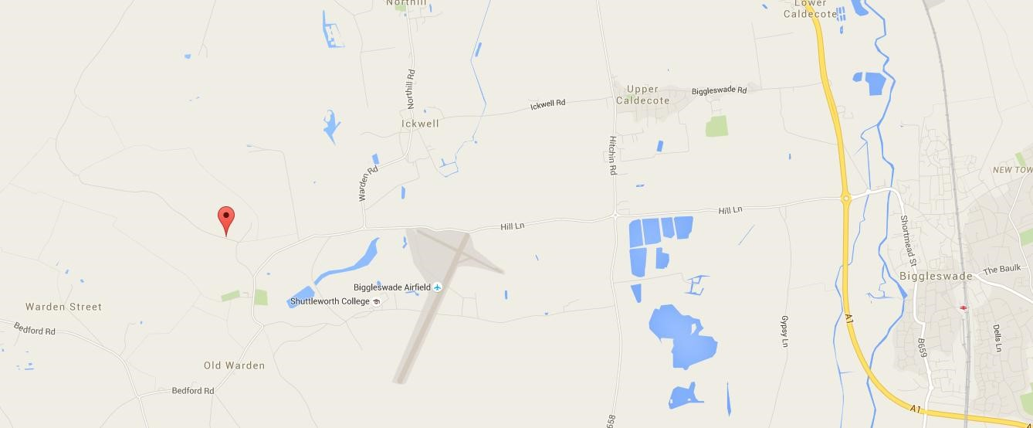

From the A1:

Take the westbound exit, signposted Old Warden and Shuttleworth, at the Biggleswade north roundabout (Sainsbury's). Continue straight on at the roundabout outside G & M Growers' Farm Shop, signposted Old Warden. Follow the road for 2 miles. Mount Pleasant Equestrian Centre is the first driveway on the right, 150 yards after the 30mph signs at the entrance of the village of Old Warden. Follow the concrete driveway around to the left and park in the yard.

From the A600:

Take the east turning towards Shuttleworth Old Warden Park (left from the north, right from the south) signposted Old Warden and Southill. Follow the road for 2½ miles, following signs to Old Warden. Continue to follow the road through the village of Old Warden. Pass a thatched bus shelter (on the right), which is opposite a warning sign for cattle (on the left); after 100 yards, the driveway for Mount Pleasant Equestrian Centre is on the left. Follow the concrete driveway around to the left and park in the yard.

CLASS ORDER OF RUNNING

Ring One  (Milton Keynes) | Ring Two  (Letchworth)
Class 7: Grade 3+4+5 Agility  Large – Medium – Small | Class 2: Grade 1 Jumping  Large – Medium – Small
Class 9: Grade 4+5+6+7 Agility  Small – Medium – Large | Class 4: Grade 1+2 Jumping  Small – Medium – Large
Class 11: Grades 1-7 Agility  Large – Medium – Small | Class 6: Grade 2+3 Jumping  Large – Medium – Small
Class 13: Allsorts Agility  Large – Medium – Small | Ring Two  (Bats)
Ring One  (Wellingborough) | Class 14: Allsorts Jumping  Small – Medium – Large
Class 1: Grade 1 Agility  Small – Medium – Large | Class 8: Grade 3+4+5 Jumping  Large – Medium – Small
Class 3: Grade 1+2 Agility  Large – Medium – Small | Class 10: Grade 4+5+6+7 Jumping  Small – Medium – Large
Class 5: Grade 2+3 Agility  Small - Medium – Large | Class 12: Grades 1-7 Jumping  Large – Medium – Small

Each club will provide a Judge and Ring Party for half a day

As we have to be out of the arena by 6pm, so we will not be stopping for lunch.

There will be a food wagon serving hot food and drinks
(hotdogs, tea, coffee etc) at the venue.

To save on costs at this Charity Event, no skips will be provided, please take all your rubbish home with you.

Chiltern Inter-Club Match – Sunday 10th November 2019

Handler | Dogs Pet Name | D.O.B. | Breed | S/M/L | Grade | Cla |  | sses |  | LHO

HANDLER DETAILS  Name………………………………………………………………………………  Address………………………………………………………..…….  …………………………………………………………………..……  Phone Number………………………………………………..……. |  | OWNER DETAILS (if different to handler)  Name…………………………………………………………………….  Address………………………………………………………………….  ……………………………………………………………………………  Phone Number………………………………………………………….

I/We undertake to abide by the regulations of this event and not to bring to the event any dog which has contracted or been knowingly exposed to any infectious or contagious disease during the 21 days prior to the event.

Owners Signature………………………………………………………………... Date……………………………………………………………………

Entry fees: £2.50 per dog per class. Entries close 18th October 2019.
Please hand completed entry form together with your entry fees to your club co-ordinator by the above date. Please check with your club co-ordinator for payment methods.

PLEASE CIRCLE YOUR CLUB BELOW  BATS LETCHWORTH MILTON KEYNES WELLINGBOROUGH |  | Number of classes entered @ £2.50 |  | = | £

